Machine Learning
: Clustering and MoG

Aim
The aim of this assignment is to become familiar with clustering using the Mixture of Gaussians model.

1. Introduction
For this lab, we will use the Peterson and Barney’s dataset of vowel formant frequencies. (For more info, look at http://speech:ucsd:edu/aldebaro/papers/klautau02_pbvowel.pdf.

More specifically, Peterson and Barney measured the fundamental frequency F0 and the first three formant frequencies (F1-F3) of sustained English Vowels, using samples from various speakers.

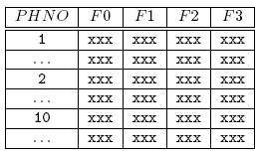
The dataset can be found at the file PB_data.mat. Load the file. In your workspace, you will have 4 vectors (F0-F3), containing the fundamental frequencies for each phoneme and another vector PHNO containing a number representing the id of the phoneme. The arrangement of the data is as follows:

In the exercises that follow, we will use only the dataset associated with formants F1 and F2.

2. MoG Modelling using the EM Algorithm

1
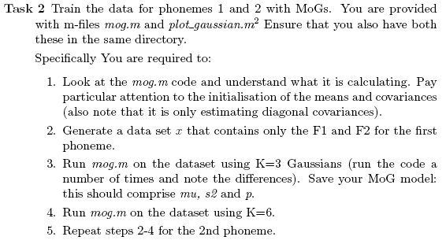
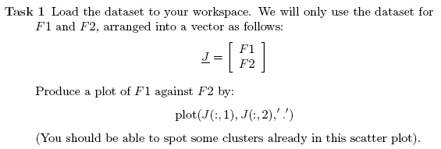

Include in your report the lines of code you wrote, and results that illustrate the learnt models.

Task 3 Use the 2 MoGs (K=3) learnt in task 2 to build a classifier to discriminate between phonemes 1 and 2. Classify using the Maximum Likelihood (ML) criterion (feel free to hack parts from the mog.m code so that you calculate the likelihood of a data vector for each of the two MoG models) and calculate the miss-classification error. Remember that a classification under the ML compares
?(?;? ), where ? are the parameters of the MoG learnt for the first phoneme, with ?(?;?2), where ?2 are the parameters of the MoG learnt for the second phoneme.

Repeat this for K=6 and compare the results.

Include in your report the lines of the code that your wrote, explanations of what the code does and comment on the differences on the classification performance.

Task 4 Create a grid of points that spans the two datasets. Classify each point in the grid using one of your classifiers. That is, create a classification matrix, M, whose elements are either 1 or 2. M(i,j) is 1 if the point ? = [?1(?),?2(?)] is classified as belonging to phoneme 1, and is 2 otherwise. ?1 is a vector whose elements are between the minimum and the maximum value of F1 for the first two phonemes, and x2 similarly for F2.

Display the classification matrix using imagesc(M).

Include the lines of code in your report, comment them, and the display the classification matrix.

Task 5 Change the code in the mog.m so that an MoG with a full covariance matrices is fit to the data. Now, create a new dataset in which each data vector J is 3 dimensional as follows:
J = [F1, F2, F1+F2]

Fit a MoG model to the new data. What is the problem that you observe? Explain why.

Suggest ways of overcoming the singularity problem and implement them.

Include the lines of code in your report, and graphs/plots so as to support your observations.

